2011 年 AMC 8 真题与解答
American Mathematics Competitions 8 · 中英双语
共 25 题，限时 40 分钟；单项选择题，每题 1 分，答错不扣分，满分 25 分。
内容来源：LIVE by Po-Shen Loh（live.poshenloh.com）历年 AMC 8 真题与解答，试题经美国数学协会（MAA）官方授权使用；本文档由本地整理生成，供个人学习使用，版权归原作者及 MAA 所有。
编排说明：第一部分为题目（先中文、后英文原题），第二部分为解答与答案，便于先做题后对答案。
第一部分 题目
第 1 题
Margie 买了 3 个苹果，每个苹果 50 美分。她用一张 5 美元纸币付款。Margie 收到多少找零？
（A）$1.50 （B）$2.00 （C）$2.50 （D）$3.00 （E）$3.50
English
Margie bought 3 apples at a cost of 50 cents per apple. She paid with a 5-dollar bill. How much change did Margie receive?
(A) $1.50 (B) $2.00 (C) $2.50 (D) $3.00 (E) $3.50
第 2 题
Karl 的长方形菜园是 20 英尺乘 45 英尺，Makenna 的菜园是 25 英尺乘 40 英尺。谁的菜园面积更大？
（A）Karl 的菜园大 100 平方英尺。 （B）Karl 的菜园大 25 平方英尺。 （C）两个菜园一样大。 （D）Makenna 的菜园大 25 平方英尺。 （E）Makenna 的菜园大 100 平方英尺。
English
Karl’s rectangular vegetable garden is 20 feet by 45 feet, and Makenna’s is 25 feet by 40 feet. Whose garden is larger in area?
(A) Karl’s garden is larger by 100 square feet. (B) Karl’s garden is larger by 25 square feet. (C) The gardens are the same size. (D) Makenna’s garden is larger by 25 square feet. (E) Makenna’s garden is larger by 100 square
feet.
第 3 题
一个正方形图案中有 8 块阴影方砖和 17 块非阴影方砖。若在该正方形周围加上一圈阴影方砖来扩展图案，扩展后阴影方砖与非阴影方砖的比是多少？
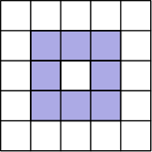
（A）8:17 （B）25:49 （C）36:25 （D）32:17 （E）36:17
English
Extend the square pattern of 8 shaded and 17 unshaded square tiles by attaching a border of shaded tiles around the square. What is the ratio of shaded tiles to unshaded tiles in the extended pattern?
(A) 8:17 (B) 25:49 (C) 36:25 (D) 32:17 (E) 36:17
第 4 题
下面是 Tyler 去年夏天九次外出钓到的鱼的数量：
2,0,1,3,0,3,3,1,2。
关于这些数的平均数、众数和中位数，哪一个说法正确？
（A）中位数 < 平均数 < 众数 （B）平均数 < 众数 < 中位数 （C）平均数 < 中位数 < 众数 （D）中位数 < 众数 < 平均数 （E）众数 < 中位数 < 平均数
English
Here is a list of the numbers of fish that Tyler caught in nine outings last summer:
2,0,1,3,0,3,3,1,2.
Which statement about the mean, mode, and median of these numbers is true?
(A) median < mean < mode (B) mean < mode < median (C) mean < median < mode (D) median < mode < mean (E) mode < median < mean
第 5 题
从 2011 年一月 1 日开始，经过 2011 分钟后是什么时间？
（A）一月 1 日晚上 9:31 （B）一月 1 日晚上 11:51 （C）一月 2 日凌晨 3:11 （D）一月 2 日上午 9:31 （E）一月 2 日下午 6:01
English
What time was it 2011 minutes after the beginning of January 1, 2011?
(A) January 1 at 9:31 PM (B) January 1 at 11:51 PM (C) January 2 at 3:11 AM (D) January 2 at 9:31 AM (E) January 2 at 6:01 PM
第 6 题
一个镇上有 351 名成年人，每个成年人拥有汽车、摩托车，或两者都有。若 331 名成年人拥有汽车，45 名成年人拥有摩托车，那么有多少名汽车拥有者不拥有摩托车？
（A）20 （B）25 （C）45 （D）306 （E）351
English
In a town of 351 adults, every adult owns a car, a motorcycle, or both. If 331 adults own cars and 45 adults own motorcycles, how many of the car owners do not own a motorcycle?
(A) 20 (B) 25 (C) 45 (D) 306 (E) 351
第 7 题
下列四个大的全等正方形分别被分成若干个全等三角形或长方形，并有部分区域被涂阴影。阴影面积占总面积的百分之多少？
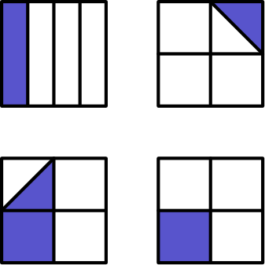
（A）12 1/2 （B）20 （C）25 （D）33 1/3 （E）37 1/2
English
Each of the following four large congruent squares is subdivided into combinations of congruent triangles or rectangles and is partially shaded. What percent of the total area is partially shaded?
(A) 12 1/2 (B) 20 (C) 25 (D) 33 1/3 (E) 37 1/2
第 8 题
A 袋中有三枚分别标有 1、3、5 的筹码。B 袋中有三枚分别标有 2、4、6 的筹码。如果从每个袋中各取出一枚筹码，两枚筹码上的数字之和可能有多少个不同的值？
（A）4 （B）5 （C）6 （D）7 （E）9
English
Bag A contains three chips labeled 1, 3, and 5. Bag B contains three chips labeled 2, 4, and 6. If one chip is drawn from each bag, how many different values are possible for the sum of the two numbers on the chips?
(A) 4 (B) 5 (C) 6 (D) 7 (E) 9
第 9 题
Carmen 在一条多坡的公路上进行长途骑行。图像显示了她骑行过程中随时间变化的行驶英里数。Carmen 整个骑行的平均速度是多少英里每小时？
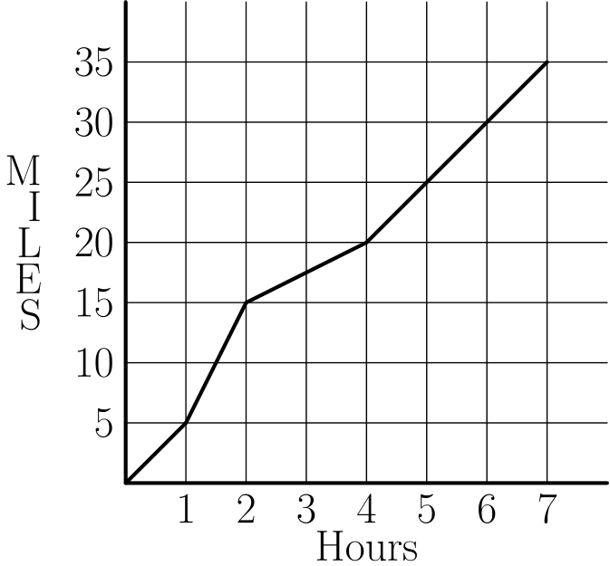
（A）2 （B）2.5 （C）4 （D）4.5 （E）5
English
Carmen takes a long bike ride on a hilly highway. The graph indicates the miles traveled during the time of her ride. What is Carmen’s average speed for her entire ride in miles per hour?
(A) 2 (B) 2.5 (C) 4 (D) 4.5 (E) 5
第 10 题
Gotham City 的出租车起步价为 $2.40，涵盖前 1/2 英里；之后的收费标准为 $0.20 每额外 0.1 英里。你计划给司机 $2 小费。用 $10 最多可以乘坐多少英里？
（A）3.0 （B）3.25 （C）3.3 （D）3.5 （E）3.75
English
The taxi fare in Gotham City is $2.40 for the first 1/2 mile and additional mileage charged at the rate $0.20 for each additional 0.1 mile. You plan to give the driver a $2 tip. How many miles can you ride for $10?
(A) 3.0 (B) 3.25 (C) 3.3 (D) 3.5 (E) 3.75
第 11 题
图中显示一周内 Asha（左柱）和 Sasha（右柱）每天学习的分钟数。平均每天 Sasha 比 Asha 多学习多少分钟？
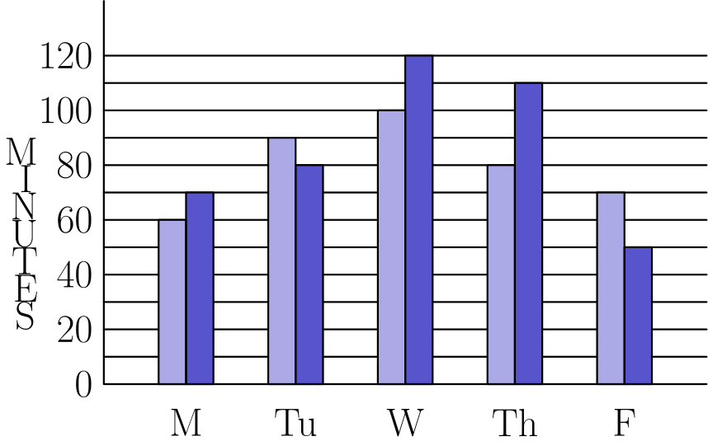
（A）6 （B）8 （C）9 （D）10 （E）12
English
The graph shows the number of minutes studied by both Asha (left bar) and Sasha (right bar) in one week. On the average, how many more minutes per day did Sasha study than Asha?
(A) 6 (B) 8 (C) 9 (D) 10 (E) 12
第 12 题
Angie、Bridget、Carlos 和 Diego 随机坐在一张方桌四周，每边坐一个人。Angie 和 Carlos 坐在相对两边的概率是多少？
（A）1/4 （B）1/3 （C）1/2 （D）2/3 （E）3/4
English
Angie, Bridget, Carlos, and Diego are seated at random around a square table, one person to a side. What is the probability that Angie and Carlos are seated opposite each other?
(A) 1/4 (B) 1/3 (C) 1/2 (D) 2/3 (E) 3/4
第 13 题
两个全等正方形 ABCD 和 PQRS 的边长均为 15。它们重叠形成图中所示的 15 乘 25 长方形 AQRD。长方形 AQRD 的面积中有百分之多少被涂阴影？
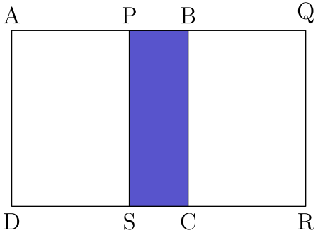
（A）15 （B）18 （C）20 （D）24 （E）25
English
Two congruent squares, ABCD and PQRS, have side length 15. They overlap to form the 15 by 25 rectangle AQRD shown. What percent of the area of rectangle AQRD is shaded?
(A) 15 (B) 18 (C) 20 (D) 24 (E) 25
第 14 题
Colfax Middle School 有 270 名学生，男生与女生的比为 5: 4。Winthrop Middle School 有 180 名学生，男生与女生的比为 4: 5。两所学校举办舞会，所有学生都参加。舞会上女生占学生总数的几分之几？
（A）7/18 （B）7/15 （C）22/45 （D）1/2 （E）23/45
English
There are 270 students at Colfax Middle School, where the ratio of boys to girls is 5: 4. There are 180 students at Winthrop Middle School, where the ratio of boys to girls is 4: 5. The two schools hold a dance and all students from both schools attend. What fraction of the students at the dance are girls?
(A) 7/18 (B) 7/15 (C) 22/45 (D) 1/2 (E) 23/45
第 15 题
乘积 4⁵ · 5¹⁰ 有多少位数字？
（A）8 （B）9 （C）10 （D）11 （E）15
English
How many digits are in the product 4⁵ · 5¹⁰?
(A) 8 (B) 9 (C) 10 (D) 11 (E) 15
第 16 题
设 A 为边长 25，25 和 30 的三角形面积。设 B 为边长 25，25 和 40 的三角形面积。A 与 B 有什么关系？
（A）A = 9/16B （B）A = 3/4B （C）A = B （D）A = 4/3B （E）A = 16/9B
English
Let A be the area of the triangle with sides of length 25, 25, and 30. Let B be the area of the triangle with sides of length 25, 25, and 40. What is the relationship between A and B?
(A) A = 9/16B (B) A = 3/4B (C) A = B (D) A = 4/3B (E) A = 16/9B
第 17 题
设 w、x、y、z 为非负整数。若
2^(w) · 3ˣ · 5ʸ · 7^(z) = 588，
那么
2w + 3x + 5y + 7z
等于多少？
（A）21 （B）25 （C）27 （D）35 （E）56
English
Let w, x, y, and z be whole numbers. If
2^(w) · 3ˣ · 5ʸ · 7^(z) = 588,
then what does
2w + 3x + 5y + 7z
equal?
(A) 21 (B) 25 (C) 27 (D) 35 (E) 56
第 18 题
一枚公平的六面骰子掷两次。第一次掷出的数大于或等于第二次掷出的数的概率是多少？
（A）1/6 （B）5/12 （C）1/2 （D）7/12 （E）5/6
English
A fair six-sided die is rolled twice. What is the probability that the first number that comes up is greater than or equal to the second number?
(A) 1/6 (B) 5/12 (C) 1/2 (D) 7/12 (E) 5/6
第 19 题
这个图形中有多少个长方形？
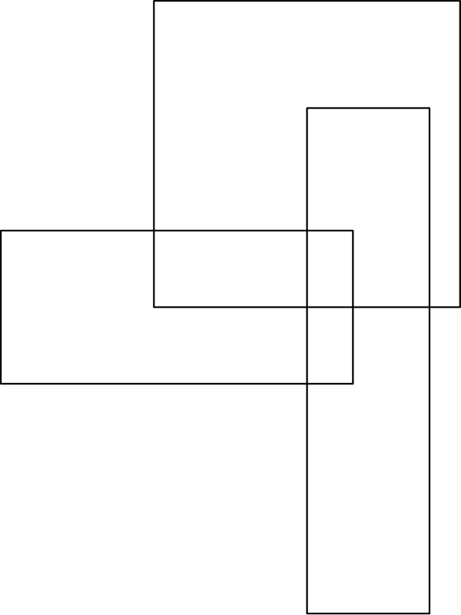
（A）8 （B）9 （C）10 （D）11 （E）12
English
How many rectangles are in this figure?
(A) 8 (B) 9 (C) 10 (D) 11 (E) 12
第 20 题
四边形 ABCD 是梯形，AD = 15、AB = 50、BC = 20，高为 12。这个梯形的面积是多少？
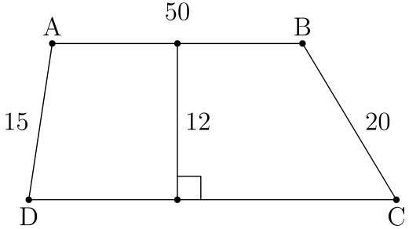
（A）600 （B）650 （C）700 （D）750 （E）800
English
Quadrilateral ABCD is a trapezoid, AD = 15, AB = 50, BC = 20, and the altitude is 12. What is the area of the trapezoid?
(A) 600 (B) 650 (C) 700 (D) 750 (E) 800
第 21 题
学生们猜 Norb 的年龄分别是 24，28，30，32，36，38，41，44，47 和 49。Norb 说：“你们中至少一半猜得太低，有两个人只差一岁，而且我的年龄是质数。”Norb 多少岁？
（A）29 （B）31 （C）37 （D）43 （E）48
English
Students guess that Norb’s age is 24, 28, 30, 32, 36, 38, 41, 44, 47, and 49. Norb says, “At least half of you guessed too low, two of you are off by one, and my age is a prime number.” How old is Norb?
(A) 29 (B) 31 (C) 37 (D) 43 (E) 48
第 22 题
7²⁰¹¹ 的十位数字是什么？
（A）0 （B）1 （C）3 （D）4 （E）7
English
What is the tens digit of 7²⁰¹¹?
(A) 0 (B) 1 (C) 3 (D) 4 (E) 7
第 23 题
有多少个 4-位正整数满足：四个数字互不相同，首位不是零，该整数是 5 的倍数，并且 5 是最大的数字？
（A）24 （B）48 （C）60 （D）84 （E）108
English
How many 4-digit positive integers have four different digits, where the leading digit is not zero, the integer is a multiple of 5, and 5 is the largest digit?
(A) 24 (B) 48 (C) 60 (D) 84 (E) 108
第 24 题
10001 可以用多少种方式写成两个质数之和？
（A）0 （B）1 （C）2 （D）3 （E）4
English
In how many ways can 10001 be written as the sum of two primes?
(A) 0 (B) 1 (C) 2 (D) 3 (E) 4
第 25 题
一个半径为 1 的圆内切于一个正方形，并外接于另一个正方形，如图所示。圆内阴影面积与两个正方形之间阴影面积的比，最接近下列哪个分数？
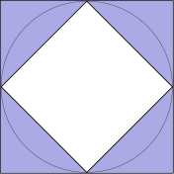
（A）1/2 （B）1 （C）3/2 （D）2 （E）5/2
English
A circle with radius 1 is inscribed in a square and circumscribed about another square as shown. Which fraction is closest to the ratio of the circle’s shaded area to the shaded area between the two squares?
(A) 1/2 (B) 1 (C) 3/2 (D) 2 (E) 5/2

第二部分 解答
答案速查：
题号 1 2 3 4 5 6 7 8 9
答案 E E D C D D C B E
题号 10 11 12 13 14 15 16 17 18
答案 C A B C C D C A D
题号 19 20 21 22 23 24 25
答案 D D C D D A A
答案串：EEDCDDCBECABCCDCADDDCDDAA
第 1 题 答案 E
苹果总共花了 3 · 50 = 150 美分，也就是 $1.50。因此 Margie 收到的找零是 $5.00-$1.50=$3.50。
所以正确答案是E。
English
The apples cost a total of 3 · 50 = 150 cents, which equals $1.50. This means that Margie received $5.00-$1.50=$3.50 in change.
Thus,Eis the correct answer.
第 2 题 答案 E
Karl 菜园的面积为
20 ft · 45 ft = 900 ft²。
Makenna 菜园的面积为
25 ft · 40 ft = 1000 ft²。
两者面积差为
1000 ft² - 900 ft² = 100 ft²。
因此 Makenna 的菜园比 Karl 的大 100 ft²。
所以正确答案是E。
English
The area of Karl’s garden is
20 ft · 45 ft = 900 ft².
The area of Makenna’s garden is
25 ft · 40 ft = 1000 ft².
The difference of these areas is
1000 ft² - 900 ft² = 100 ft².
Therefore, Makenna’s garden is 100 ft² larger than Karl’s.
Thus,Eis the correct answer.
第 3 题 答案 D
原图案是一个 5×5 的正方形。每边向外扩展一块方砖后，得到一个 7×7 的正方形，所以新增加的阴影边框有 7²-5²=24 块方砖。加上原来的 8 块阴影方砖，共有 24+8=32 块阴影方砖。原来的 17 块非阴影方砖不变，因此阴影方砖与非阴影方砖之比为 32:17。
所以正确答案是D。
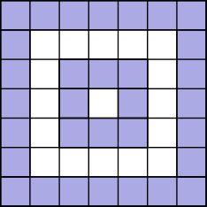
English
The original pattern is a 5×5 square. Extending it by one tile on every side makes a 7×7 square, so the new shaded border contains 7²-5²=24 tiles. Together with the original 8 shaded tiles, there are 24+8=32 shaded tiles. The original 17 unshaded tiles do not change, so the ratio of shaded tiles to unshaded tiles is 32:17.
Thus,Dis the correct answer.
第 4 题 答案 C
为了更容易求这些值，先得到有序列表：
0, 0, 1, 1, 2, 2, 3, 3, 3。
由此可知众数是 3，中位数是 2，平均数是 15/9 = 5/3。
因为 5/3 < 2 < 3，所以有：
平均数 < 中位数 < 众数。
所以正确答案是C。
English
To find these values more easily, we can get the following ordered list:
0, 0, 1, 1, 2, 2, 3, 3, 3.
From this, we see that the mode is 3, the median is 2, and the mean is 15/9 = 5/3.
Since 5/3 < 2 < 3, we get that:
mean < median < mode.
Thus,Cis the correct answer.
第 5 题 答案 D
2011 除以 60 的余数是 31。也就是说 2011 = 60 · 33 + 31，所以 2011 分钟等于 33 小时 31 分钟。
经过 24 小时到达一月 2 日，所以此时已过去 9 小时 31 分钟，也就是 2 日上午。
所以正确答案是D。
English
The remainder when 2011 is divided by 60 is 31. This means that 2011 = 60 · 33 + 31, which means that 2011 minutes is the same as 33 hours and 31 minutes.
24 hours takes us to January 2, so we get that we are 9 hours and 31 minutes into January 2.
Thus,Dis the correct answer.
第 6 题 答案 D
已知有 45 人拥有摩托车，所以 351 - 45 = 306 人不拥有摩托车。
所以正确答案是D。
English
We know that 45 people own motorcycles, so 351 - 45 = 306 people do not own motorcycles.
Thus,Dis the correct answer.
第 7 题 答案 C
左上和右下的阴影区域各占所在正方形的四分之一。右上占八分之一，左下占八分之三。它们的总面积为
1/4 + 1/4 + 1/8 + 3/8 = 1。
因此阴影区域合起来等于一个正方形的面积，占四个正方形总面积的 25 %。
所以正确答案是C。
English
The top left and the bottom right shaded regions are both a quarter of each square. The top right is one-eighth, and the bottom left is three-eighths. Their combined area is
1/4 + 1/4 + 1/8 + 3/8 = 1.
Therefore, the shaded regions combined equal the area of one square, so they are 25 % of the total area.
Thus,Cis the correct answer.
第 8 题 答案 B
表格列出了全部九种结果。不同的和为 3,5,7,9 和 11，所以共有 5 个可能的值。
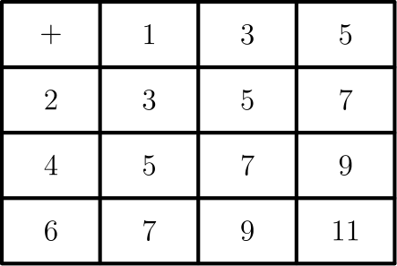
所以正确答案是B。
English
The table shows all nine outcomes. The distinct sums are 3,5,7,9, and 11, so there are 5 possible values.
Thus,Bis the correct answer.
第 9 题 答案 E
Carmen 共行驶 35 英里，用时 7 小时，所以平均速度为 35/7 = 5 英里每小时。
所以正确答案是E。
English
Carmen travels 35 miles in 7 hours, so her average speed is 35/7 = 5 miles per hour.
Thus,Eis the correct answer.
第 10 题 答案 C
小费固定为 $2，从总额中减去后剩 $8。这大于 $2.40，所以再减去前半英里的车费，并把 1/2 英里计入总距离。
现在还有 $5.60 可用于额外里程。收费标准为 $0.20 每 0.1 英里，等价于 $2 每 1 英里。因此这笔钱还能乘坐 5.60/2 = 2.8 英里。总距离为 2.8 + 1/2 = 3.3 英里。
所以正确答案是C。
English
There is a guaranteed $2 tip, so we can subtract that from the total, leaving $8. This is greater than $2.40, so we can subtract that and add 1/2 miles to the total distance.
We now have $5.60 to use for additional miles. $0.20 per 0.1 mile is the same as $2 for 1 mile. That means one can ride for 5.60/2 = 2.8 more miles with this much money. This leaves a total of 2.8 + 1/2 = 3.3 miles.
Thus,Cis the correct answer.
第 11 题 答案 A
可以通过每天的差值来计算平均分钟数之差。
从星期一开始，Sasha 与 Asha 的差值分别为 10、-10、20、30、-20。总差为 30 分钟，因此平均差为 30 ÷ 5 = 6。
所以正确答案是A。
English
We can calculate the difference in average minutes by looking at the differences per day.
Starting with Monday, the differences between Sasha and Asha are 10, -10, 20, 30, and -20. This is a total of 30 minutes. Therefore, the average difference is 30 ÷ 5 = 6.
Thus,Ais the correct answer.
第 12 题 答案 B
设 Angie 的座位已经确定。Carlos 等可能坐在另外 3 个座位中的任意一个，但其中只有一个座位与 Angie 相对。因此概率为 1/3。
所以正确答案是B。
English
Consider that Angie’s seat is chosen. Carlos has an equal probability of being in any of the other 3 seats. Only one of them is opposite Angie, however. Therefore, the probability is 1/3.
Thus,Bis the correct answer.
第 13 题 答案 C
有
SC = DC + SR - DR
= 15 + 15 - 25
= 5
。
因此 PBSC 的面积为 5 · 15 = 75。AQRD 的面积为 25 · 15 = 375。
75/375 = 1/5，也就是 20 %。
所以正确答案是C。
English
We get that
SC = DC + SR - DR
= 15 + 15 - 25
= 5.
This means that the area of PBSC is 5 · 15 = 75. The area of AQRD is 25 · 15 = 375.
75/375 = 1/5, which is 20 %.
Thus,Cis the correct answer.
第 14 题 答案 C
女生总数为
4/9 · 270 + 5/9 · 180 =
120 + 100 = 220。
学生总数为 270 + 180 = 450，所以女生所占比例为 220/450 = 22/45。
所以正确答案是C。
English
The total number of girls is
4/9 · 270 + 5/9 · 180 =
120 + 100 = 220.
There are 270 + 180 = 450 students total, so the fraction of girls is 220/450 = 22/45.
Thus,Cis the correct answer.
第 15 题 答案 D
为了求位数，可以尝试把这个数写成 10 的幂。
有
4⁵ · 5¹⁰ = 2¹⁰ · 5¹⁰
= 10¹⁰
。
这说明所求数是 1 后面跟着 10 个零，共有 11 位数字。
所以正确答案是D。
English
To find the number of digits, we can try to express this number in terms of powers of 10.
We get that
4⁵ · 5¹⁰ = 2¹⁰ · 5¹⁰
= 10¹⁰.
This shows that the desired number is 1 followed by 10 zeros, for a total of 11 digits.
Thus,Dis the correct answer.
第 16 题 答案 C
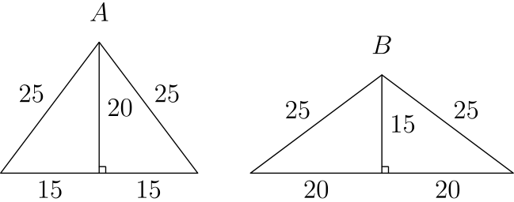
因为这两个三角形都是等腰三角形，图中从顶点作出的高会平分底边，并把每个三角形分成两个全等的直角三角形。
由勾股定理，面积为 A 的三角形的高为
√(25² - 15²) = 20。
类似地，面积为 B 的三角形的高为
√(25² - 20²) = 15。
因此
A = 1/2 · 20 · 30 = 300。
同样，
B = 1/2 · 15 · 40 = 300。
所以 A = B。
所以正确答案是C。
English
Since these triangles are isosceles, the altitude shown from the apex of each triangle bisects its base and creates two congruent right triangles.
Using the Pythagorean theorem, we get that the altitude of the triangle with area A equals
√(25² - 15²) = 20.
Similarly, we get that the altitude of the triangle with area B equals
√(25² - 20²) = 15.
With these altitudes, we can calculate the areas of the triangles. We get that
A = 1/2 · 20 · 30 = 300.
Similarly,
B = 1/2 · 15 · 40 = 300.
Therefore, A = B.
Thus,Cis the correct answer.
第 17 题 答案 A
为了找到所需指数，注意所有底数都是质数。因此质因数分解会有帮助。
有
588 = 2² · 3¹ · 7²。
由此可知 w = 2、x = 1、y = 0 且 z = 2，其中 y = 0 使 5ʸ 这一项等于 1。
代入这些指数可得
2w + 3x + 5y + 7z
= 2 · 2 + 3 · 1 + 5 · 0 + 7 · 2
= 21
。
所以正确答案是A。
English
To find the desired exponents, note that all the bases are prime numbers. This means that finding the prime factorization will be helpful.
We get that
588 = 2² · 3¹ · 7².
From this, it is clear that w = 2, x = 1, y = 0, and z = 2 (y = 0 since that makes the 5ʸ term equal 1).
Therefore,
2w + 3x + 5y + 7z
= 2 · 2 + 3 · 1 + 5 · 0 + 7 · 2
= 21.
Thus,Ais the correct answer.
第 18 题 答案 D
掷骰子两次时有 3 类结果：第一次大于第二次、两次相等、第一次小于第二次。第一类和第三类由于对称而概率相同。
第二类发生的概率是 1/6，因为第一次可以是任意数，而第二次必须等于第一次。其余两类的总概率为 1 - 1/6 = 5/6。因此每一类的概率为 5/6 ÷ 2 = 5/12。
所求概率是第一类加第二类，共为 5/12 + 1/6 = 7/12。
所以正确答案是D。
English
There are 3 possible outcomes when rolling a die twice: the first number is greater than the second, both numbers are equal, or the first number is less than the second number. The first and third outcomes have the same probability since they are symmetric.
The second outcome has a 1/6 chance of happening, since the first number can be anything, and the second number must equal the first number. The other two outcomes have a combined probability of 1 - 1/6 = 5/6. This means that each outcome has a 5/6 ÷ 2 = 5/12 chance of happening.
The desired probability is the first outcome plus the second outcome, for a total probability of 5/12 + 1/6 = 7/12.
Thus,Dis the correct answer.
第 19 题 答案 D
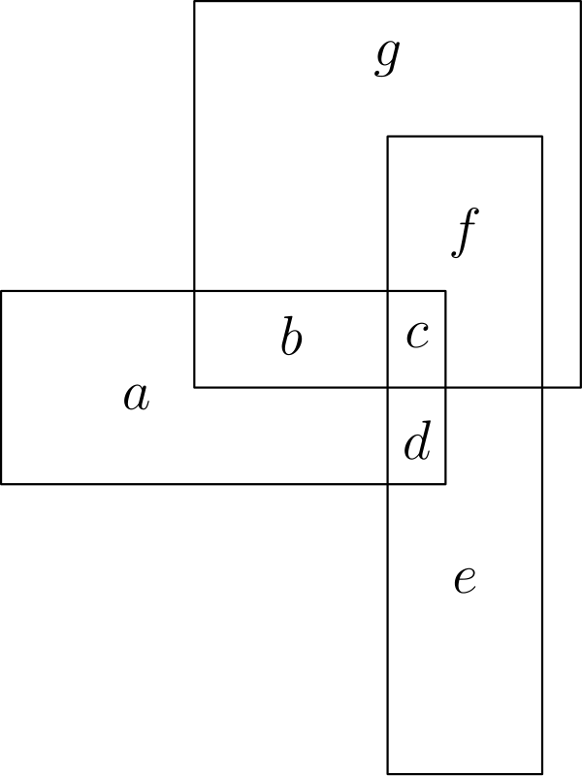
可以把图形分成这些区域，使统计长方形更容易。
图中的长方形是 b、c、d、ab、bc、cd、cf、de、abcd、cdef 和 bcfg。这些共有 11 个长方形。
所以正确答案是D。
English
We can split the figure into these regions to make it easier to count the rectangles.
The rectangles in this figure are b, c, d, ab, bc, cd, cf, de, abcd, cdef, and bcfg. These form 11 rectangles.
Thus,Dis the correct answer.
第 20 题 答案 D
可以作如下高，更容易求面积。
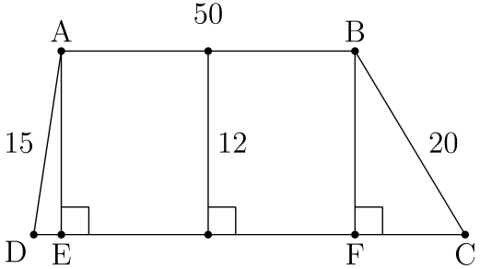
用勾股定理可得
DE = √(15² - 12²) = 9
且
FC = √(20² - 12²) = 16。
还知道
EF = AB = 50，
所以
DC = DE + EF + FC = 75。
因此 ABCD 的面积为
1/2 · (DC + 50) · 12 = 6 · 125
= 750。
所以正确答案是D。
English
We can drop the following altitudes to more easily find the area.
We can use the Pythagorean Theorem to get that
DE = √(15² - 12²) = 9
and
FC = √(20² - 12²) = 16.
We also know that
EF = AB = 50,
so
DC = DE + EF + FC = 75.
Then the area of ABCD is
1/2 · (DC + 50) · 12 = 6 · 125
= 750.
Thus,Dis the correct answer.
第 21 题 答案 C
陈述的第一部分表示 Norb 的年龄大于 36。
第二部分表示 Norb 的年龄要么在 36 和 38 之间，要么在 47 和 49 之间。
因为 37 是质数而 48 不是，所以 Norb 的年龄是 37。
所以正确答案是C。
English
The first part of the statement means that Norb’s age is greater than 36.
The second part means that Norb’s age is either between 36 and 38 or between 47 and 49.
Since 37 is prime and 48 is not, Norb’s age is 37.
Thus,Cis the correct answer.
第 22 题 答案 D
要找十位数字，只需跟踪 7 的幂模 100 的结果。因为 7⁴=2401≡1pmod100，末两位每四次方重复。
因为 2011=4·502+3，所以
7²⁰¹¹≡7³=343
≡43pmod100
因此十位数字是 4。
所以正确答案是D。
English
To find the tens digit, it is enough to track powers of 7 modulo 100. Since 7⁴=2401≡1pmod100, the last two digits repeat every four powers.
Because 2011=4·502+3, we have
7²⁰¹¹≡7³=343
≡43pmod100
Thus the tens digit is 4.
Thus,Dis the correct answer.
第 23 题 答案 D
一个数能被 5 整除，个位数字必须是 0 或 5。
如果个位数字是 0，另外三位中必须有一位是 5。剩下两位必须从 {1, 2, 3, 4} 中选择。有 6 种方式选这两个数字，并有 6 种方式排列这三位数字，共 6 · 6 = 36 个数。
如果个位数字是 5，千位数字有 4 种选择。选定千位后，其他数字共有 4 · 3 = 12 种方式填入中间 2 位。因此此情况共有 4 · 12 = 48 个数。
合并两种情况，总数为 36 + 48 = 84。
所以正确答案是D。
English
For a number to be divisible by 5, the units digit must be either 0 or 5.
If the units digit is 0, one of the other three digits must be 5. The remaining two digits must be chosen from {1, 2, 3, 4}. There are 6 ways to choose the pair, and there are 6 ways to arrange the three digits for a total of 6 · 6 = 36 numbers.
If the units digit is 5, there are 4 ways to choose the thousands digit. There are 4 · 3 = 12 ways to choose the other 2 digits. This leaves a total of 4 · 12 = 48 numbers for this case.
Combining both cases, we get the total number of such integers is 36 + 48 = 84.
Thus,Dis the correct answer.
第 24 题 答案 A
两个数相加得到奇数时，一个必须是奇数，另一个必须是偶数。唯一的偶质数是 2，所以另一个数只能是 9999。但 9999 不是质数，因此 10001 不能写成两个质数之和。
所以正确答案是A。
English
For two numbers to add to an odd number, one of them must be odd and the other even. Thus the only even prime is 2, so the other number is forced to be 9999. 9999 is not prime, however, so 10001 cannot be written as the sum of two primes.
Thus,Ais the correct answer.
第 25 题 答案 A
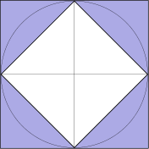
圆内阴影面积等于圆面积减去小正方形面积。内正方形的边长可由勾股定理求得：
√(1² + 1²) = √(2)。
因此内正方形面积为 √(2)² = 2。圆内阴影面积为 1²π - 2 = π - 2。
外正方形面积为 2² = 4，所以两个正方形之间的阴影面积为 4 - 2 = 2。
所求比值为
(π - 2)/2 ≈ (3.14 - 2)/2 ≈ 1/2。
所以正确答案是A。
English
The circle’s shaded area is equal to the area of the circle minus the area of the smaller square. The side length of the inner square can be calculated using the Pythagorean Theorem to get
√(1² + 1²) = √(2).
Therefore, the area of the inner square is √(2)² = 2. The circle’s shaded area is then 1²π - 2 = π - 2.
The area of the outside square is 2² = 4, so the shaded area between the two squares is 4 - 2 = 2.
The desired fraction is
(π - 2)/2 ≈ (3.14 - 2)/2 ≈ 1/2.
Thus,Ais the correct answer.

